Home work-2

1.Design vacuum cleaner with any 4 different shapes of you choice, Each code
should at least accept “start”, “stop”, “right”, “left” and “dock”. Rest is up to
your imagination. Look each shape offers unique advantage, now that’s
something you need extract for your advantage and also justify why a particular
shape is better

Input:

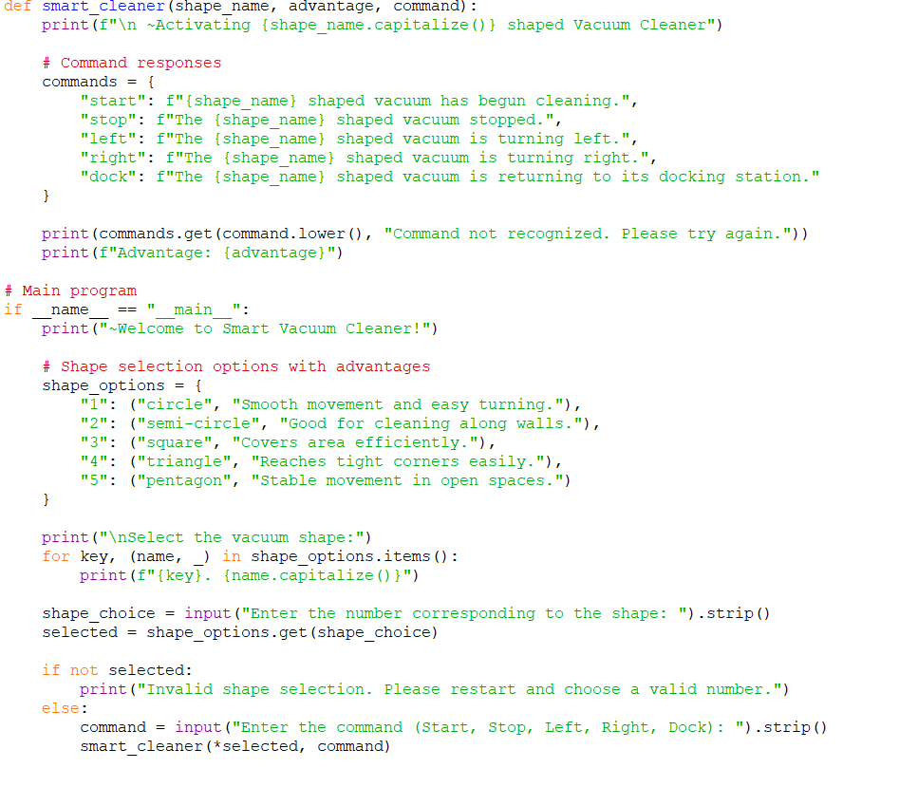
Output:

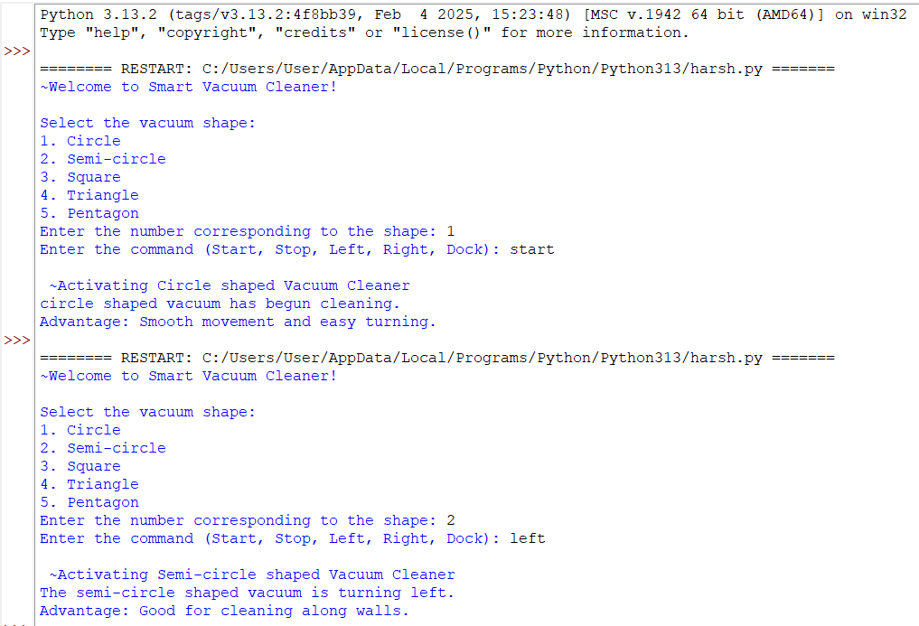

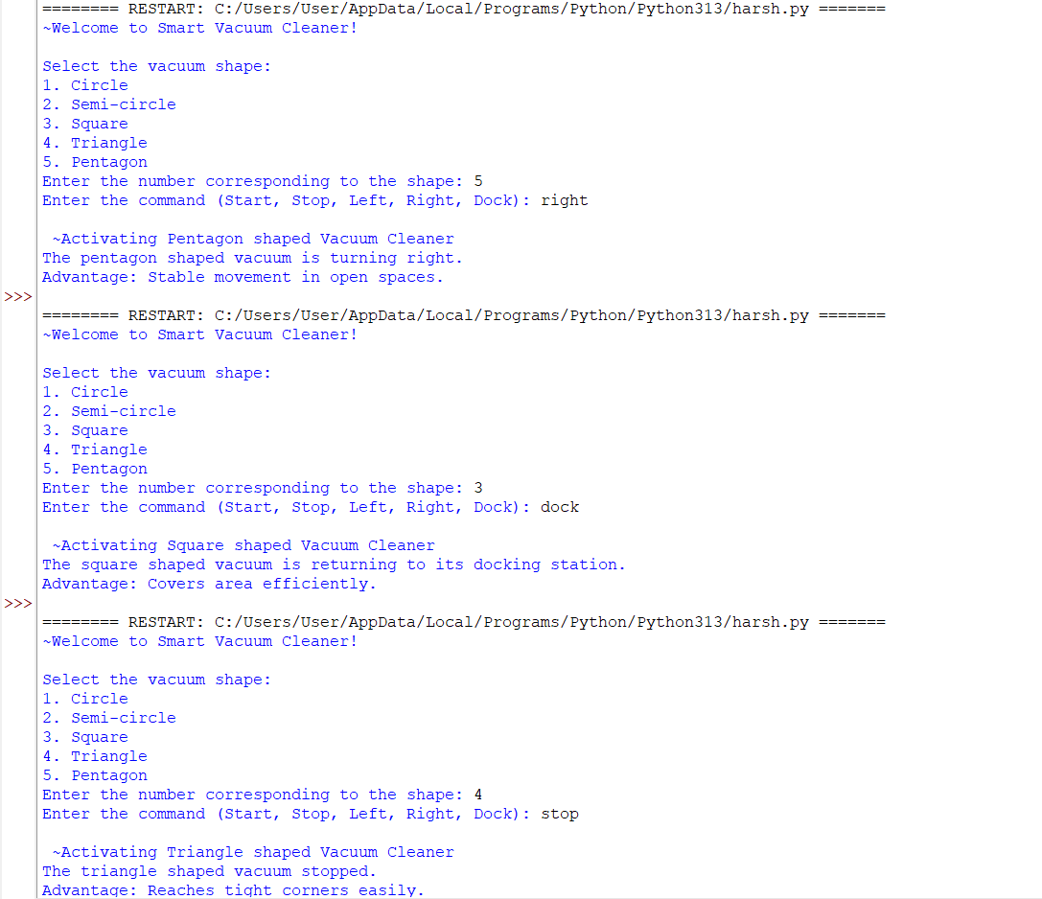

Code:

def smart_cleaner(shape_name, advantage, command):
print(f"\n ~Activating {shape_name.capitalize()} shaped Vacuum Cleaner")

# Command responses
commands = {
"start": f"{shape_name} shaped vacuum has begun cleaning.",
"stop": f"The {shape_name} shaped vacuum stopped.",
"left": f"The {shape_name} shaped vacuum is turning left.",
"right": f"The {shape_name} shaped vacuum is turning right.",
"dock": f"The {shape_name} shaped vacuum is returning to its docking station."
}

print(commands.get(command.lower(), "Command not recognized. Please try again."))
print(f"Advantage: {advantage}")

# Main program
if _name_ == "_main_":
print("~Welcome to Smart Vacuum Cleaner!")

# Shape selection options with advantages
shape_options = {
"1": ("circle", "Smooth movement and easy turning."),
"2": ("semi-circle", "Good for cleaning along walls."),
"3": ("square", "Covers area efficiently."),
"4": ("triangle", "Reaches tight corners easily."),
"5": ("pentagon", "Stable movement in open spaces.")
}

print("\nSelect the vacuum shape:")
for key, (name, _) in shape_options.items():
print(f"{key}. {name.capitalize()}")

shape_choice = input("Enter the number corresponding to the shape: ").strip()
selected = shape_options.get(shape_choice)

if not selected:
print("Invalid shape selection. Please restart and choose a valid number.")
else:
command = input("Enter the command (Start, Stop, Left, Right, Dock): ").strip()
smart_cleaner(*selected, command)

